Lab – 01
Name: Abid Rafique Khan
BITS ID: 2021WA86438
Course: Introduction to Devops
Course ID: CSIW ZG515

Case 1:
You have been asked to lead a Project of Web Development for which four people are working on Java and JavaScript code. You need to manage code with help of GIT Project by following below steps:

- Create a Project with name Web-Dev in Local Repository
- Create Two Branches "Java" and "JavaScript"
- Create Test Script and Increase Versioning in each Branch
- Merge Branches to Master "Web-Dev
- Push to code to Server

Observation:
In this task, I created a local repository named 'Web-Dev' and worked with two separate branches, 'Java' and 'JavaScript'. Each branch included an initial test script to simulate independent work done by team members. After committing the individual changes, both branches were successfully merged into the 'master' branch. Lastly, the repository was pushed to GitHub using SSH authentication, ensuring secure and centralized version control.

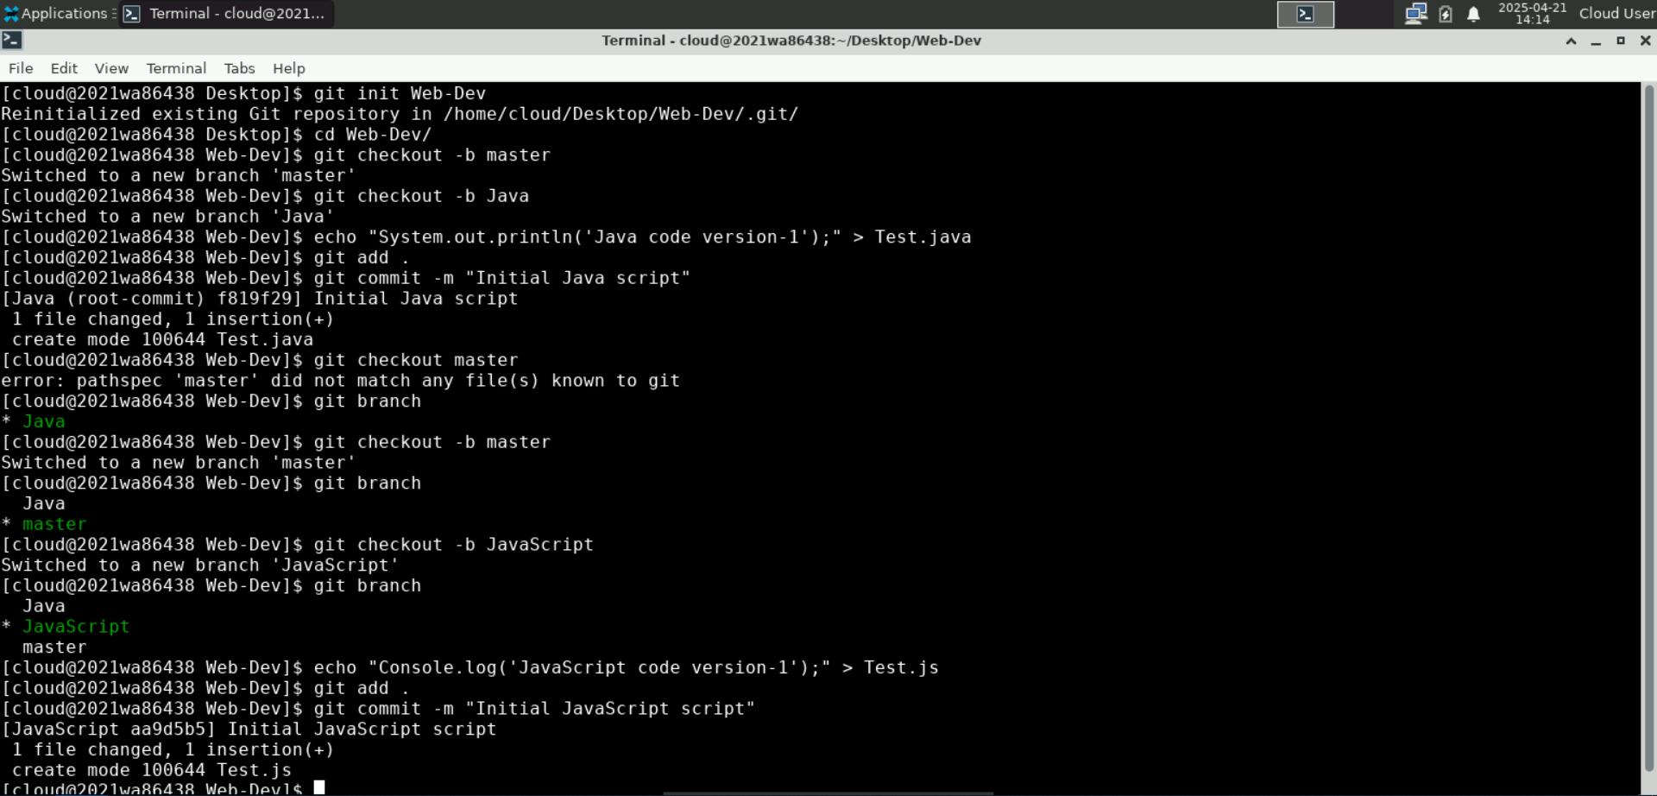
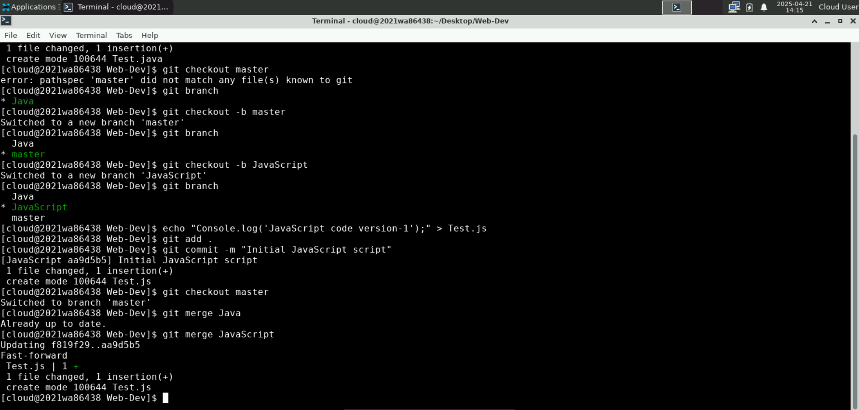

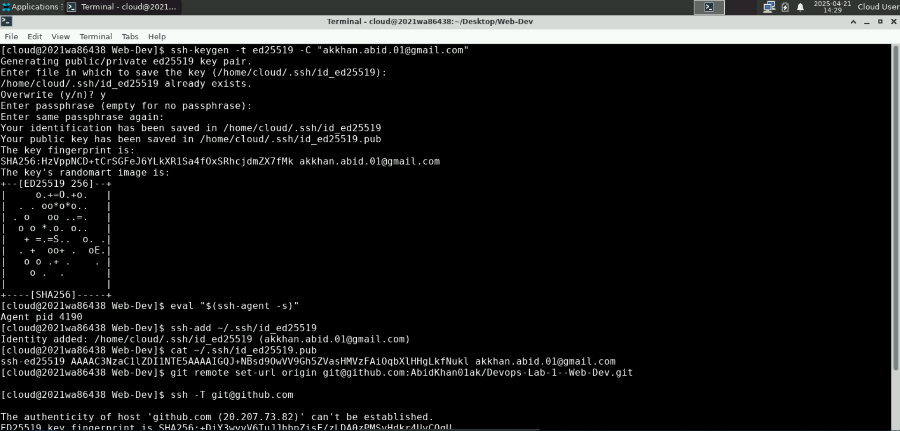
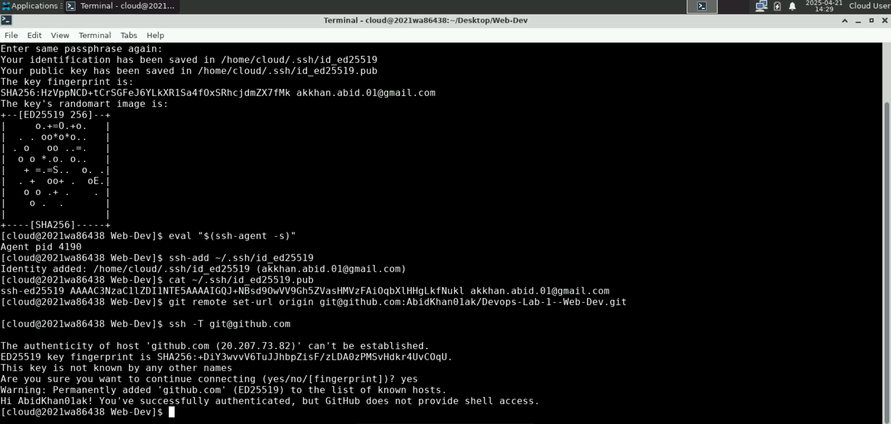
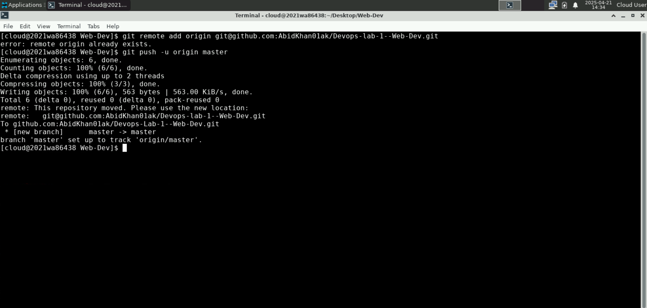
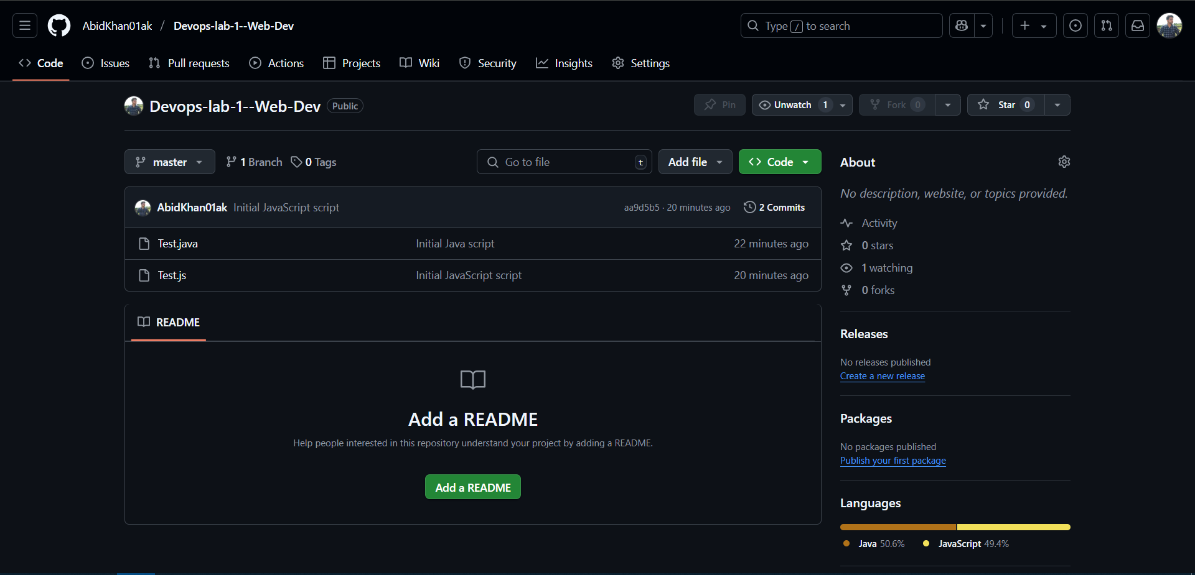
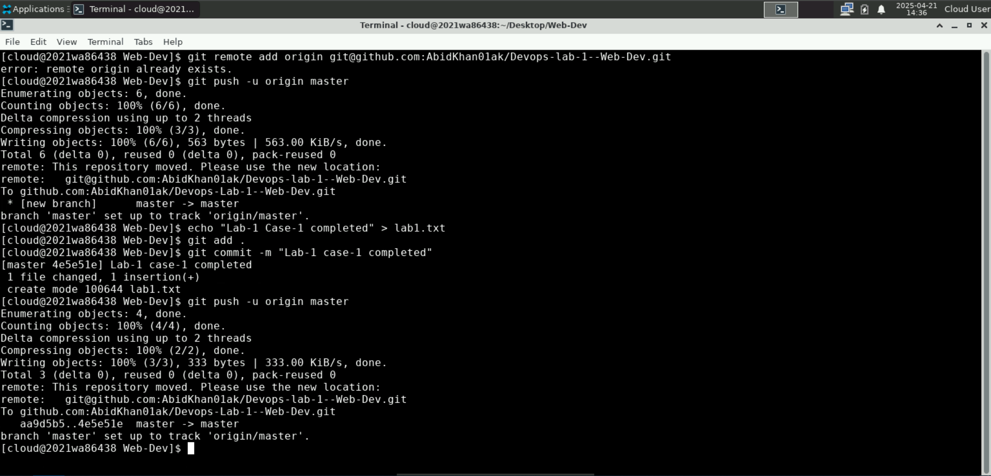

Case 2:
Considering you as Member of PMO Office working across the different locations, You are working on Planning & Inventory of a Project, where you will be keep appending data to the existing files and may add new files. You are asked to manage the versioning and repository available at a central location:

Steps to be followed:
- Create a GitHub Account
- Start a new Project called "PMO-Office"
- Add on some Excel Sheet for Inventory
- Commit the Changes
- Create a Local Repository [On Your Laptop]
- Add few more file in Local Repo
- Commit the changes in Local Repo
- Push the files to Server

Observation:
For the PMO Office simulation, a new repository was created on GitHub named 'PMO-Office'. I initialized a local repository, added planning documents (such as Notes.txt), and committed them. Since the remote repository already had an initial commit, a pull was required using '--allow-unrelated-histories' to merge both codebases. After resolving the sync, all files were successfully pushed to the server.

